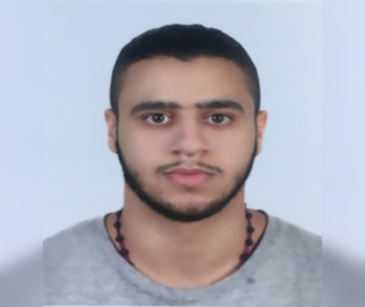

**Career Objective:-**

* Seeking a suitable job according to my qualification, skills and talent, this to gain more knowledge and experiance for a bright career.

**Personal Details:-**

Name : Ammar Moh'd Ahmed

Address : Villa: 1042, Road: 2331 Jid-hafs

Nationality : Bahrain

Date of Birth : 14-09-1998

Sex : Male

Marital Status : Single

Religion : Muslim

CPR No : 980904196

Telephone : +973-32006333

Email : ammarmohamed1998@gmail.com

**Working Skill:-**

- Ability to Do Work In Every Kind of Situation.

- Hard Working and Punctual.

- Communication in Every Situation.

- Be Able To Work As Team And Individually.

**Language:-**

- English ( writting and speaking) .

- Arabic ( writting and speaking) .

**Educational Qualification:-**

- Secondary school .

**Working Experience:-**

- Work as a * Risk And Compliace * Supervisor in Majid Al_futtaim (2 years).

**Declaration:-**

- I Request Your Good Self To Give Me An Opportunity In Your Reputed Concern. I Assure You Sir, That I Will Discharge My Duties To The Entire Satisfaction Of All My Superiors. I Shall Obey The Rules And Regulations Of Your Concerer .